Engagement MIS Manual
  - Prepared for: Engagement & Collaboration
26-FEB-2013

Contents
SECTION A 2
1. OVERVIEW 2
2. ACCESSING THE SYSTEM 4
SECTION B 9
3. CAPTURING A NEW ENGAGEMENT ACTIVITY/PROJECT 9
3.1. Project/Activity Definition 13
3.2. Management of Project/Activity 16
3.3. Nature of Project/Activity 17
3.4. Community Interaction, Service & Outreach (CSIO) 18
3.5. Professional/Discipline-based Service Provision (P/Db) 20
3.6. Teaching and Learning (T&L) 22
3.7. Research and Scholarship (R&S) 23
3.8. External Partnerships 24
3.9. Budget / Funding / Legal / Contractual 26
3.10. Team Members 28
3.11. Human Resources 32
3.12 Project Monitoring 33
SECTION C 34
4. EDITING YOUR ENGAGEMENT ACTIVITY/PROJECT 34
SECTION D 37
5. PRINT A COPY OF YOUR ENGAGEMENT ACTIVITY/PROJECT 37
SECTION E 42
6. REPORTING / MIS 42
SECTION F 44
7. ADMINISTRATION OF THE ENGAGEMENT MIS SYSTEM (MIS Administrator) 44
8. CONCLUSION 49

SECTION A

1. OVERVIEW
NMMU Engagement MIS system is a central system that allows all NMMU Engagement Activities and Projects to be captured by the relevant departments for the purpose of monitoring and evaluation of engagement projects, as well as providing a consolidated database where all external collaboration and projects can be recorded and reported on. This system serves as a central repository for Engagement documentation in an access restricted environment. The vision is for all areas of engagement to be able to capture their own projects, external and internal stakeholders onto a common system from where a history can be kept of past and current engagement by the various departments at the NMMU.
The NMMU Engagement MIS system focuses on collecting information as pertaining to the various categories of engagement at the NMMU namely, (1) Community Interaction, Service & Outreach, (2) Engagement through Professional/Discipline based Provision, (3) Teaching & Learning, and (4) Research & Scholarships.
A high-level diagram of the process is represented below:
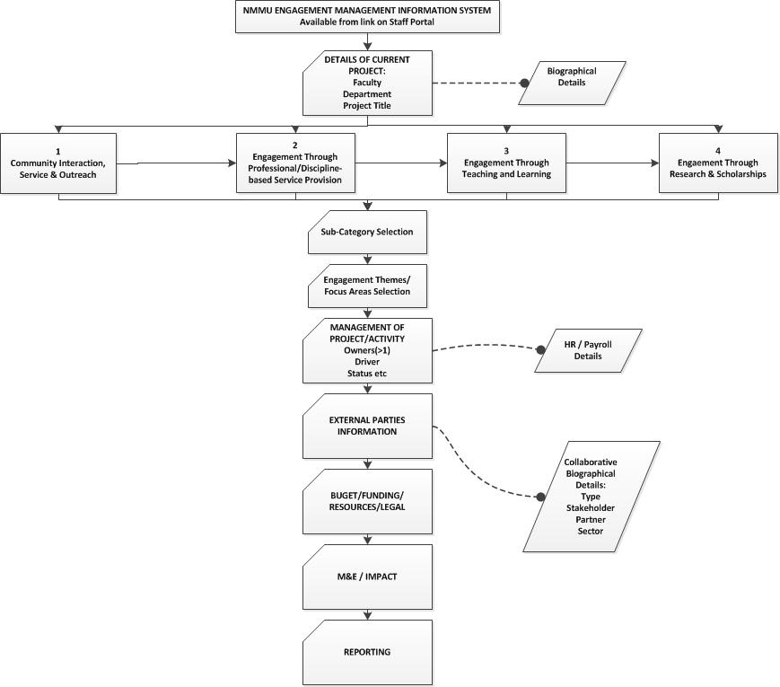

2. ACCESSING THE SYSTEM
A link to the Engagement MIS site can be found on the Staff Portal under “Online Forms ->Tools&Services->Engagement & Collaboration->Engagement MIS”. The direct link to the SharePoint site is https://depts.nmmu.ac.za/Engagement/SitePages/Home.aspx, accessible to all staff. Academics and other staff related to engagement with external parties can capture and update their specific project/activity information here.
Access is governed through the Microsoft Active Directory (AD) of the university ensuring that only staff members can see their own information, and staff to whom they have decided to grant access.
Upon accessing the system, this page will be displayed:
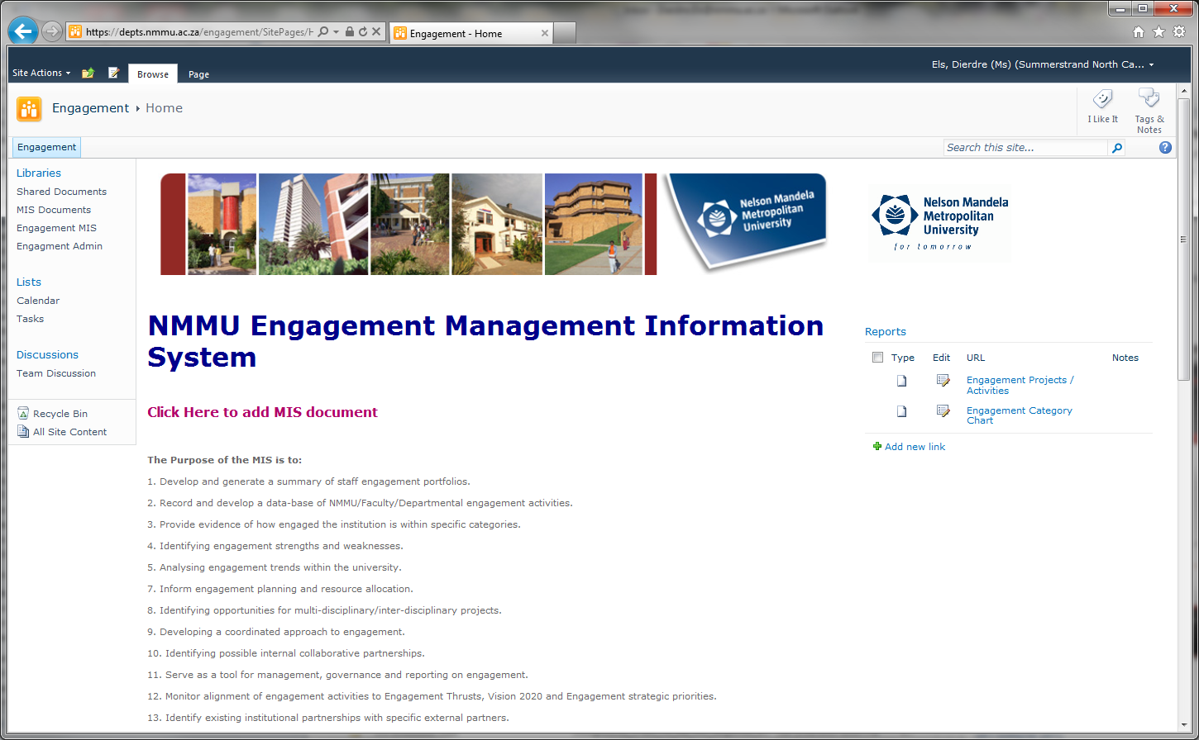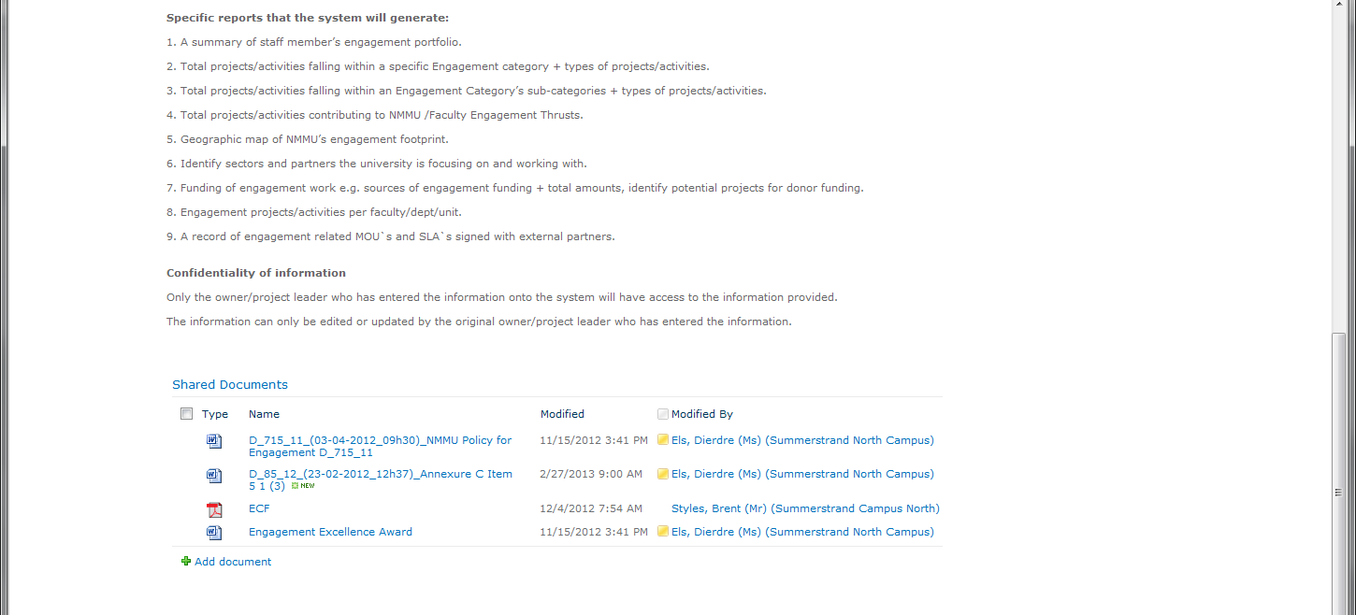
Overview of Entire Engagement MIS Home Page
The Left Hand Panel contains links into the system for creating a new Engagement MIS activity (“Engagement MIS”), Viewing previously entered activities or Projects (“Engagement MIS”), for Administration of the Engagement MIS system (“Engagement Admin”) and for uploading documents relative to your Engagement Activity (“MIS Documents”):
Left Hand Panel of Engagement MIS Home Page

The center panel contains the heading, a shortcut link to create a new activity (Click Here to add MIS document), a textual overview of the system, and relevant shared documents at the bottom:
Centre Panel of Engagement MIS Home Page

The Right Hand Panel contains any reports that have been created for the Engagement MIS system:
Right Hand Panel of Engagement MIS Home Page

SECTION B

3. CAPTURING A NEW ENGAGEMENT ACTIVITY/PROJECT
There are two ways to initially capture a new activity or project.
Firstly, you can click on the “Engagement MIS” link in the Left Hand panel of the page,
and then click on “Add Document”:
Alternatively you can click on “Click Here to add MIS document” in the center panel of the page:
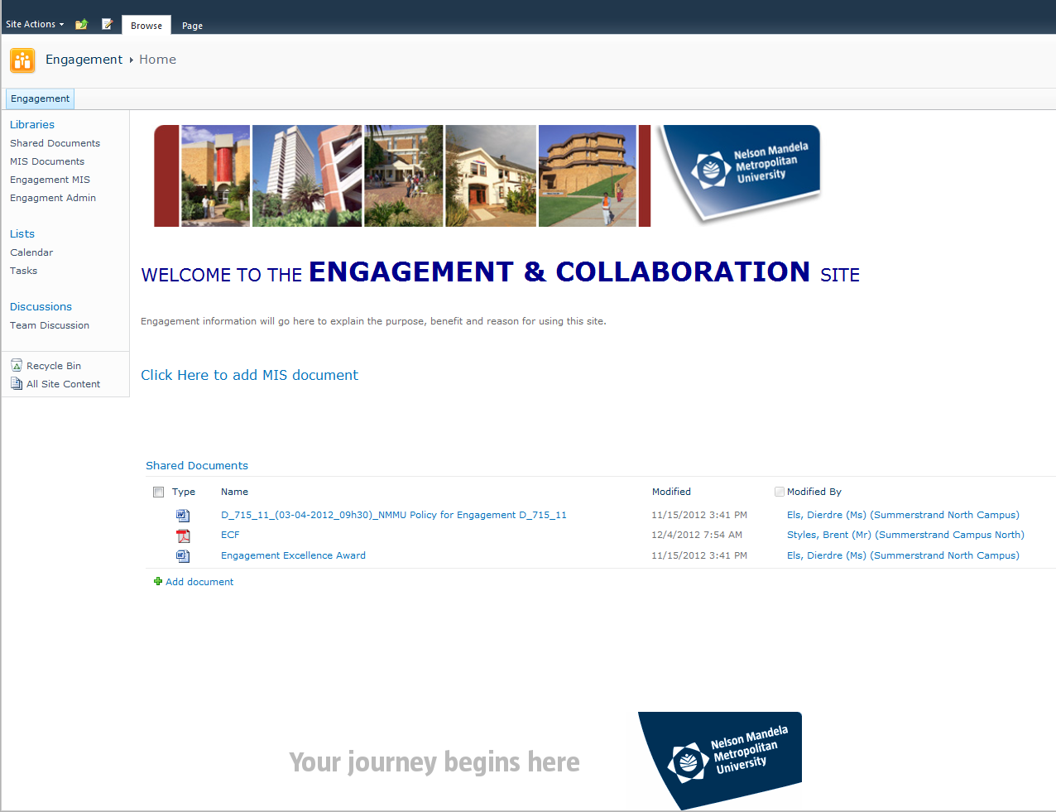
An input form like looking like this will then be displayed:
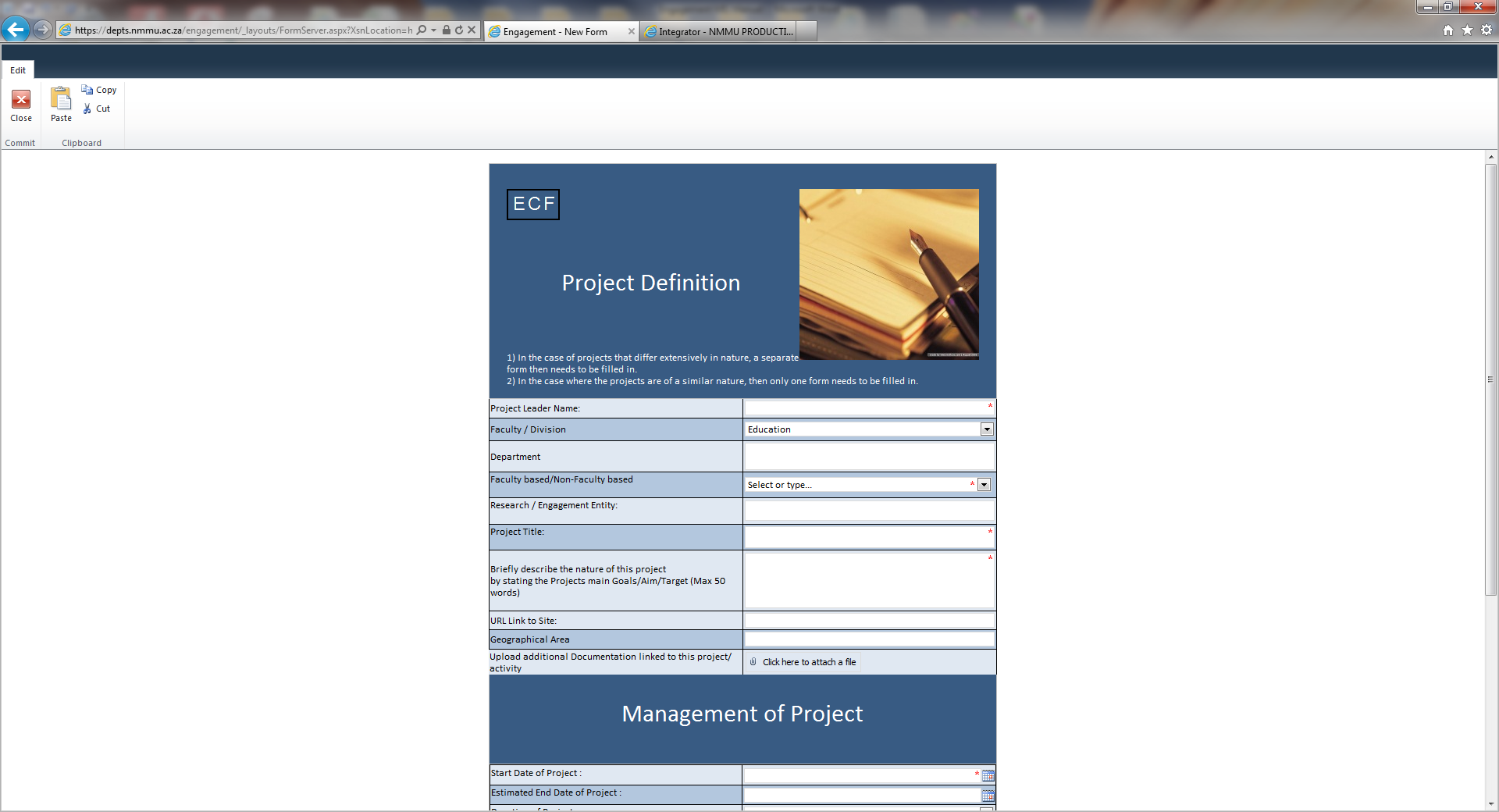

Take note of the functionality in the top left hand corner of the screen that allows you to Close the form, Copy, Cut and Paste:
The Engagement Conceptual Framework (ECF) at the top of the form is a link to supporting documentation that can be viewed by clicking on the “EFC” letters:
The data captured in these forms are validated against ITS as far as possible, and is saved into a central database. This will reduce having to re-capture the same information every year.

3.1. Project/Activity Definition
Start by capturing the details of your Engagement Activity/Project:

Various drop-down lists will be used from other data-sources like ITS where possible. For example, the Faculty drop-down list displays a list of Faculties as drawn from ITS.

This form also allows you to attach a document should you wish. Simply select the file to attach from your local PC:

3.2. Management of Project/Activity

Click on “Next” to continue.
Fields that are mandatory are indicated by a red asterisk (*).
If not all the mandatory fields have been completed, it will display this error message at the bottom of the form:

3.3. Nature of Project/Activity
Next you can select the Nature of the Engagement activity/project. Four Engagement categories are given as specified in the ECF. You can select a minimum of one, and maximum of four as it pertains to your Engagement Activity.
If you are not sure which is the most relevant category in which your engagement project/activity falls click on Engagement Conceptual Framework (ECF) which provides some examples per category for your guidance.

3.4. Community Interaction, Service & Outreach (CSIO)
Activities contributing to Public good, upliftment and development of the external community informed by the staff member’s expertise.
Depending on the category chosen, you will be directed to either this page for CISO, or another page for one of the other engagement categories. Here the various options will be presented with tick-boxes as more than one can be selected per category. A maximum of 3 can be selected.

3.5. Professional/Discipline-based Service Provision (P/Db)
Activities that contribute to the advancement of the discipline, profession, public debate and socio-economic development.
A maximum selection of 3 is allowed. If more than 3 are selected, the following error will be displayed:

3.6. Teaching and Learning (T&L)
Activities that provide students the opportunity for applied learning and the deepening of student and staff civic responsiveness, and responding to the training needs of non-traditional markets.

3.7. Research and Scholarship (R&S)

3.8. External Partnerships
The main external partner must be selected from a pre-defined list that is maintained by the Engagement system administrator.

Collaboration partners and beneficiaries can subsequently be added. Once the information has been captured, you will need to click on the “Add Partner(s)” button to add the partner to the list below before further partners can be specified.

3.9. Budget / Funding / Legal / Contractual
Here the source of funding can be specified, whether Internal or External, as well as any Contractual or Legal requirements of the Engagement Activity.
Do not place an “R” for rand value or thousand separators as this will automatically be done upon entering the value.

3.10. Team Members
Team Members are all the people working on this Engagement Activity/Project. They can either be an Internal Staff member or someone Externally.
By typing the Staff number in the first field and clicking “Get Details”, the fields will automatically be populated from ITS. You can still edit this data before clicking on “Add Team Member” to save it to the Project activity.
In order to capture an External Team Member, leave the staff number field blank, and manually type in the rest of the fields, followed by “add Team Member” to save them to the Project Activity.

At this point you can click on “Grant Staff Permissions”. This functionality allows you to give access to only those staff members you would like to have access to your Project / Activity on the Engagement MIS site.
Select the Staff member from the AD email picker: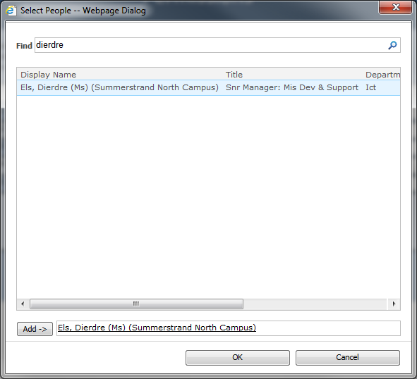
Click on “Add User to Permission List”, and once you have all the staff members you want to have access to this Engagement Activity/Project, click on “GRANT ACCESS” to activate the permissions.

3.11. Human Resources
At this point you can give an indication of the Paid and Volunteer staff and students involved with the Project/Activity.

3.12 Project Monitoring
The type and timeframe of any reporting or monitoring done with regards to the Engagement Project/Activity can be indicated on this form.
At this point you have completed the Capturing of your Engagement Project /Activity and can “Submit” it to the Engagement Database. If you do not submit, none of the data you have entered will be saved. Once you Project/Activity has been submitted, it will be displayed on the Engagement MIS list.

SECTION C

4. EDITING YOUR ENGAGEMENT ACTIVITY/PROJECT
You can edit any non-mandatory information in your project by going back to it at a later stage. The screen you will now enable you to go directly to any one of the sections you would like to edit.

For example, if you click on Project Definition, it will allow you to edit the Project Definition page again:
On the Engagement MIS Site, you can click on your Project /Activity displayed in the list, and it will take you to the Editing screen as well.

SECTION D

5. PRINT A COPY OF YOUR ENGAGEMENT ACTIVITY/PROJECT
On the Edit screen there is an option to “Print Document”. This will display all of the information entered on one screen so that you can print it out if necessary.

SECTION E

6. REPORTING / MIS
Reports can be found on the Right Hand Side of the Engagement Home Page. More reports can be added as needed.
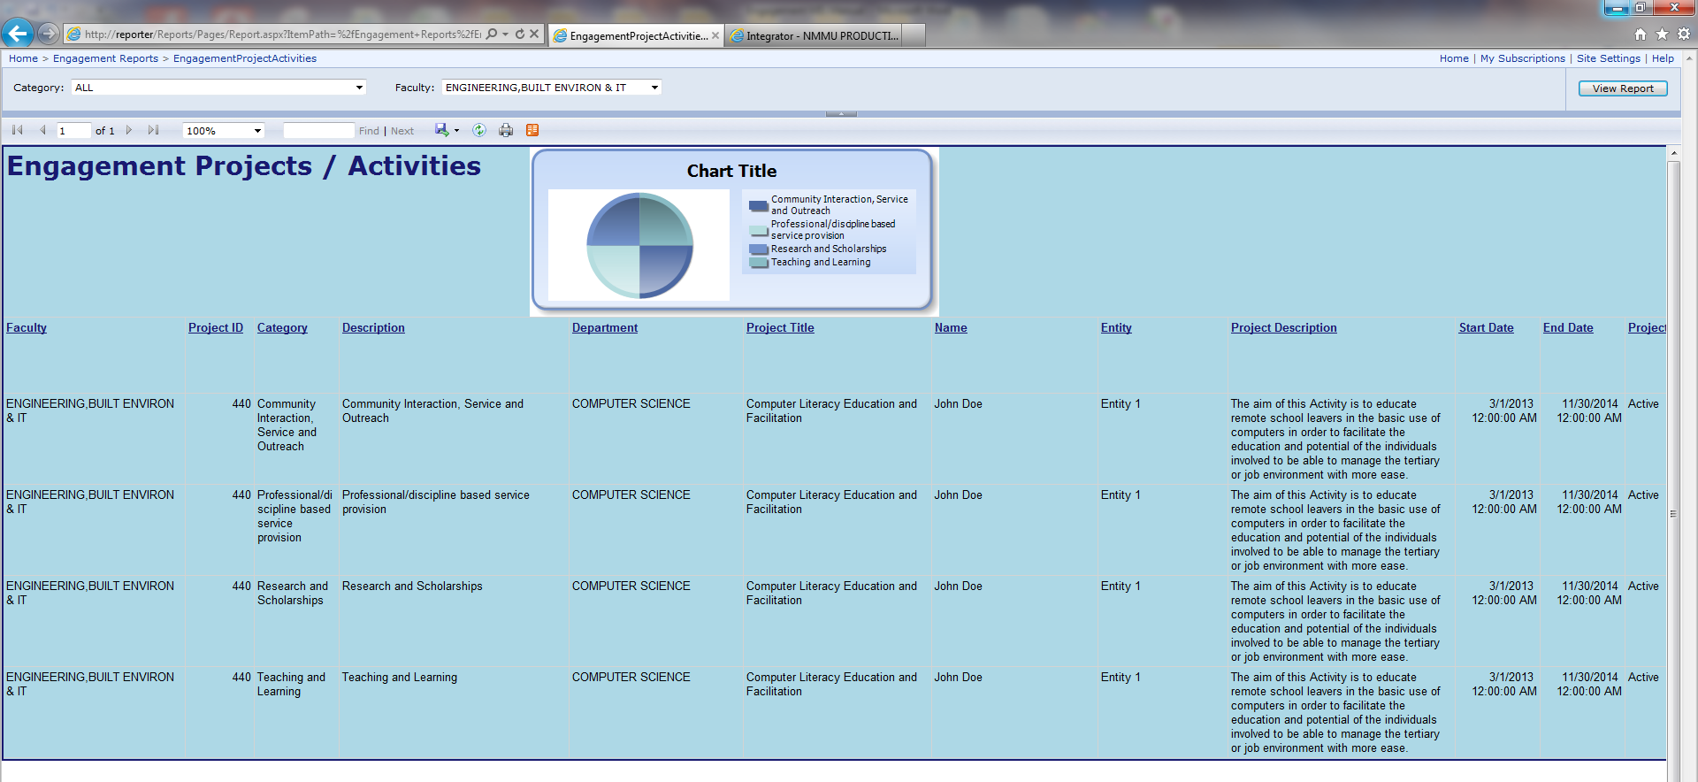

Specific reports can be developed, but access to the MIS database can also be made available for the administrator of the Engagement MIS system for statistical purposes.

SECTION F

7. ADMINISTRATION OF THE ENGAGEMENT MIS SYSTEM (MIS Administrator)
On the Left panel of the Engagement Home screen, there is a link to “Engagement Admin” from where the Engagement MIS administrator can add, delete or edit certain information in the system like Categories, sub-categories and External Partners.
Only the Engagement MIS administrator will have access to the administrator forms.
The “Engagement Admin” link takes you to the Administrator screen. To open click “Add Document”:

8. CONCLUSION
Onus will be on the academics from other departments to capture their own information, but this database will provide a much needed source of data for Engagement and Collaboration with external parties that can be used for statistical and other purposes.

